MS DYNAMICS AX Vs DYNAMICS 365

**An Overview of Dynamics AX and Dynamics 365**

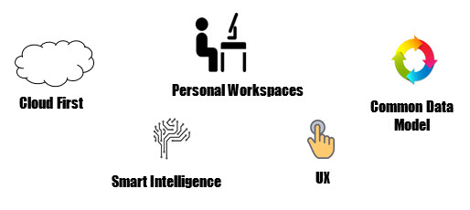

As you weigh your options, two systems you are sure to consider are Microsoft’s Dynamics AX and the all-new Dynamics 365. So what defines these systems? Let’s have a look at some of the basic components of both these systems:

**Make Smarter Business Decisions:**

While Dynamics AX is primarily an on-premises ERP solution providing the core functionality you need to make smart business decisions, the new AX solution is also available as a cloud or hybrid solution – just like Dynamics 365 is – bringing the power, speed and intelligence of cloud computing to people for organizations to achieve more.

**Improve Day-to-Day Efficiency:**

The personal workspace concept aids you in doing your day-to-day tasks easily and quickly. With a list of suggested priorities, you can first take up tasks that need special attention, and make sure you meet the required deadlines.

**Seamless User Experience:**

With the all new user experience, you can work anytime, anywhere, and from any device. The natural UI accelerates adoption, while raising productivity and user satisfaction. The seamless touch interface facilitates smooth access on multiple devices, allowing you to get all your work done in time.

**Deeper Insight into Your Business:**

The built-in [smart intelligence](https://synoptek.com/insights/it-blogs/3-ways-dynamics-crm-2016-analytics-will-take-you-to-the-next-level) and the combination of Cortana Intelligence, Power BI, and Azure Machine Learning built in, enables deep insights into business performance. Create stunning interactive reports, get the intelligence you need, and answers to your questions through rich visuals and dynamic charts on the device of your choice.

**Simplify Data Management:**

The presence of the Common Data Model (CDM) helps in simplifying data management and integration across apps and business processes. Analyze massive amounts of data to get a unified view, connect this data with information in other Microsoft apps, and empower employees to maximize results. Build custom entities specific to your business domain and connect them to Microsoft developed apps or third-party apps for added customization.

**What Makes Dynamics AX and Dynamics 365 Similar?**

Both Dynamics AX and Dynamics 365 are similar in a lot of ways: built-in with exceptional [Business intelligence capabilities](https://synoptek.com/business-process-and-software-solutions/data-insights/), offering a stunning user experience, and enabling you to develop stunning dashboards through its high-end reporting features.

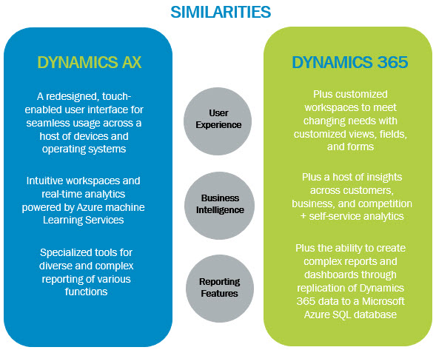

**Dynamics AX vs Dynamics 365: What’s Makes Them Different?**

While Dynamics AX and Dynamics 365 are similar in many ways, there are an overwhelming amount of differences between the two of them – from the infrastructure on which they both are deployed, to their licensing options, integration capabilities, and scalability and development options.

Below you will find a chart that provides a solid overview of the key differences between Dynamics AX and Dynamics 365.

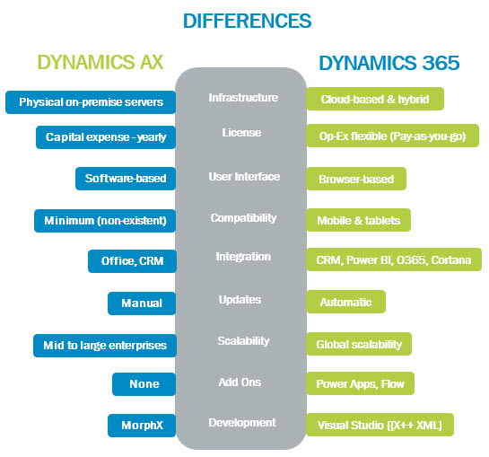

**Take the Best Step Forward**

As markets mature, industries undergo transformation, and technological innovations become more and more pervasive, getting insights into your business, competition, and customers is critical for success. Microsoft Dynamics AX and Dynamics 365 are built with analytics at the foundation, offering you the insights required for business excellence. Depending on the features you need, its important you carefully analyze both solutions, and choose the one that best fits your needs.

Looking for ways to get the most out of your enterprise solutions? Download our free ebook, *Transform the Way You Do Business with a Unified Platform for ERP and CRM.*